

**MECHATRONICS SYSTEM INTEGRATION (MCTA 3203)**

**SEMESTER 1 2024/2025**

**WEEK 3B: SERIAL COMMUNICATION**

**SECTION 2**

**GROUP 8**

**LECTURER: ZULKIFLI BIN ZAINAL ABIDIN & WAHJU SEDIONO**

| NO. | GROUP MEMBERS | MATRIC NO. |
| --- | --- | --- |
| 1. | AHMAD DARWISH BIN AHMAD TERMIZI | 2212089 |
| 2. | SYABAB ALHAQQI BIN JAAFAR | 2211117 |
| 3. | WAN NAIMULLAH BIN MOHD AZRUDDIN | 2214837 |
| 4. | ZAIMUDIN ZAKWAN BIN NORZAMRI | 2217513 |
| 5. | ZAMIR MUTTAQIN BIN MUHAMMAD BALYAN | 2212985 |

Date of Experiment: Wednesday, 23 October 2024

Date of Submission: Wednesday, 30 October 2024

## **ABSTRACT**

This experiment explores serial communication between a Python script and an Arduino to control a servo motor’s angle. By sending angle data from Python to the Arduino, the servo motor adjusts accordingly, allowing for remote, programmable control. The setup aims to demonstrate fundamental concepts in microcontroller interfacing and serial communication, utilising simple input-output (I/O) operations and providing a foundation for more complex sensor-actuator systems.

TABLE OF CONTENTS

| NO | CONTENT | PAGE |
| --- | --- | --- |
| 1 | INTRODUCTION | 4 |
| 2 | MATERIALS AND EQUIPMENTS | 5 |
| 3 | EXPERIMENTAL SETUP | 5 |
| 4 | METHODOLOGY | 6 |
| 5 | DATA COLLECTION | 8 |
| 6 | DATA ANALYSIS | 8 |
| 7 | RESULTS | 9 |
| 8 | DISCUSSION | 9 |
| 9 | CONCLUSION | 9 |
| 10 | RECOMMENDATIONS | 10 |
| 11 | REFERENCES | 10 |
| 12 | ACKNOWLEDGEMENT | 10 |
| 13 | DECLARATION | 11 |

## **INTRODUCTION**

The purpose of this experiment is to demonstrate serial communication between an Arduino and a computer using Python to control a servo motor’s position. The experiment introduces students to basic serial communication principles, allowing real-time angle input from a Python script to the Arduino, which actuates a servo motor. This interaction offers a practical understanding of controlling hardware through software commands, a foundational skill in mechatronics and embedded systems. The hypothesis is that the Arduino will accurately receive angle data from Python and adjust the servo to the specified angle, demonstrating successful serial communication and control.

## **MATERIALS AND EQUIPMENTS**

1. ARDUINO MEGA 2560
2. SERVO MOTOR
3. JUMPER WIRES

## **EXPERIMENTAL SETUP**

1. Connect the potentiometer to the Arduino with one leg to 5V, the other to GND, and the middle (wiper) to the analog input pin A0.
2. Connect the servo motor to the Arduino with the red one to the 5V, the orange one to pin D9, and the brown one to the GND.
3. Connect the Arduino to the computer via USB, as shown in Figure 1, and run the Python script to begin reading potentiometer values in the terminal.
4. Adjust the potentiometer knob to observe the values displayed in real-time.
5. To view real-time data on the Arduino Serial Plotter, close the Python script.
6. Open the Serial Plotter from “Tools” and “Serial Plotter” in the Arduino IDE.
7. Ensure the correct COM port and baud rate (9600) are selected.
8. Observe and customise the data graph as the potentiometer is turned.

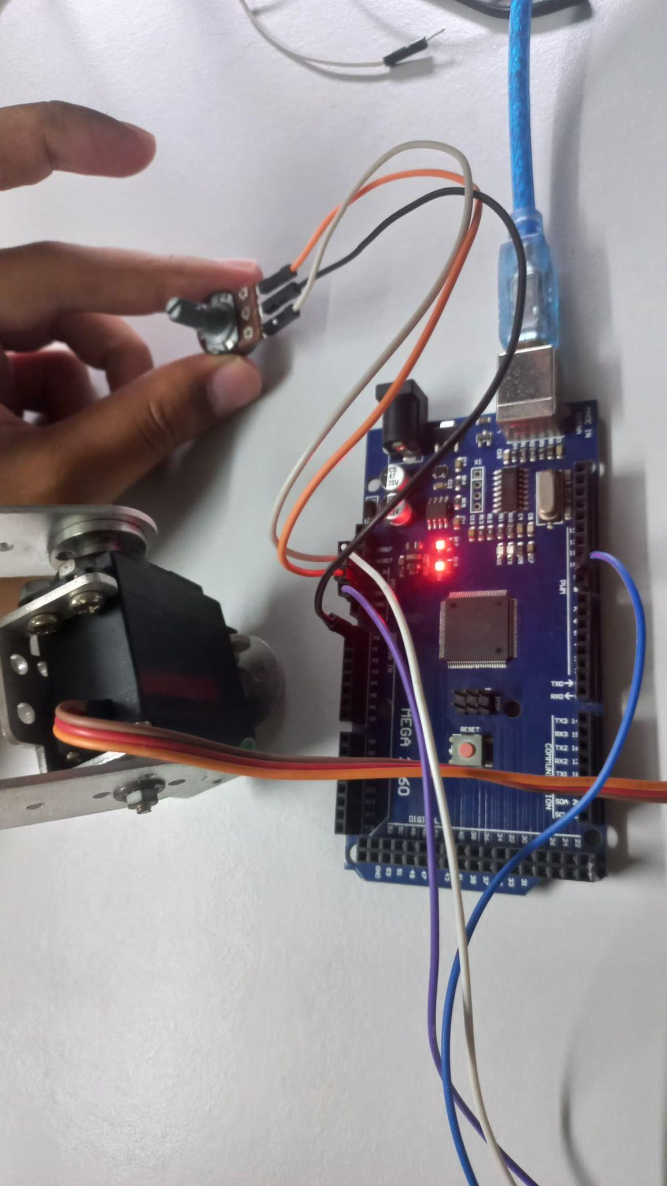

**Figure 1**

**METHODOLOGY**

1. Setup the Arduino Mega 2560
2. IDE code implementation
3. Python code implementation
4. Run the python script
5. Experiment the servo angle
6. Read the angle in python terminal
7. Code snippet

**Arduino code**

const int potPin = A0;

#include <Servo.h>

Servo servo;

int value = 0;

int angle = 0;

void setup() {

// put your setup code here, to run once:

servo.attach(9);

pinMode(9, OUTPUT);

pinMode(potPin, INPUT);

Serial.begin(9600);

}

void loop() {

// put your main code here, to run repeatedly:

value = analogRead(potPin);

angle = map(value, 0, 1023, 0, 180);

Serial.println(angle);

servo.write(angle);

delay(200) ;

}

**Python code**

import serial

import time

import keyboard # Requires 'keyboard' library for keypress detection

arduino_port = "COM7"

baud_rate = 9600

# Establish serial communication with Arduino

ser = serial.Serial(arduino_port, baud_rate)

time.sleep(2) # Allow time for connection to establish

print("Press 's' to stop the servo control.")

try:

while True:

# Check for user input to send stop command to Arduino

if keyboard.is_pressed('s'):

ser.write(b's') # Send 's' to Arduino to stop the loop

print("Stop command sent to Arduino.")

break

# Read and display the servo angle (0-180 degrees) sent from Arduino

if ser.in_waiting > 0:

angle = ser.readline().decode().strip()

print(f"Servo Angle: {angle}°")

time.sleep(0.1) # Small delay to prevent high CPU usage

except KeyboardInterrupt:

print("Process interrupted by user.")

finally:

ser.close()

print("Serial connection closed.")

**DATA COLLECTION**

| **Potentiometer Reading** | **Servo Angle (°)** |
| --- | --- |
| 0 | 0 |
| 128 | 23 |
| 256 | 45 |
| 384 | 68 |
| 512 | 90 |
| 640 | 113 |
| 768 | 135 |
| 896 | 158 |
| 1023 | 180 |

**DATA ANALYSIS**

From table 1, the servo angle varies for each potentiometer input due to the potentiometer voltage. The angle given is rounded up because the python script does not give any decimal points. Based on this data, we can make use of the precise angle of the servo that reacts to potentiometer value for any mechanism that requires precise movement. It can vary in angles from 0 to 180 degrees that makes up for most of the mechanisms that require precise control movement. For example, a robotic arm needs to do precise movements in various angles. Thus, this is a perfect application using a servo motor and a potentiometer.

**RESULT**

The experiment successfully demonstrated serial communication between a Python script and Arduino, enabling accurate control of the servo motor’s location using angle data received via a potentiometer. The servo motor precisely adjusted to the received angle values, showcasing effective control and integration. Real-time feedback displayed the servo angle within the Python terminal, allowing for continuous monitoring and verification of the system's accuracy and responsiveness. Observations of system reaction time were recorded, with any possible delays in communication or motor response identified as places to improve. Figures and tables would help to elucidate these findings by graphically exhibiting angle values, servo locations, and reaction times, providing a thorough summary of the data.

**DISCUSSION**

The results confirm that serial communication between Python and Arduino is reliable for controlling a servo motor, demonstrating the feasibility of using serial commands for real-time control. By sending angle commands from Python, the Arduino precisely actuates the servo, showing that software can effectively manage hardware operations remotely.

Minor sources of error include occasional data transmission delays and potential COM port selection issues, both of which can be minimised with proper setup and configuration. Ensuring accurate baud rate matching and error handling in both the Arduino and Python code reinforces data integrity and smooth communication. This experiment’s success highlights serial communication’s potential for broader applications in robotics and IoT systems.

**CONCLUSION**

The report concluded that the experiment successfully showed serial communication between Python and Arduino, allowing the control of the servo motor through input commands by potentiometer. This confirms the hypothesis and provides valuable insights into the principles of mechatronics system integration, emphasising the reliability and capability of microcontroller interfacing.

**RECOMMENDATIONS**

1. Code Optimization: I recommend optimizing both Arduino and Python scripts for smoother serial communication and enhanced response time.
2. Additional Components: Proposes use of more advanced components for better accuracy and functionality when controlling the servo motor.

**REFERENCES**

Serial communication between python and arduino : <https://projecthub.arduino.cc/ansh2919/serial-communication-between-python-and-arduino-663756>

**ACKNOWLEDGEMENTS**

Special thanks to ZULKIFLI BIN ZAINAL ABIDIN & WAHJU SEDIONO for their guidance and support during this experiment.

**Certificate of Originality and Authenticity**

This is to certify that we are **responsible** for the work submitted in this report, that **the** **original work** is our own except as specified in the references and acknowledgement, and that the original work contained herein have not been untaken or done by unspecified sources or persons. We hereby certify that this report has **not been done by only one individual** and **all of us have contributed to the report**. The length of contribution to the reports by each individual is noted within this certificate. We also hereby certify that we have **read** and **understand** the content of the total report and no further improvement on the reports is needed from any of the individual’s contributors to the report. We therefore, agreed unanimously that this report shall be submitted for **marking** and this **final printed report** has been **verified by us.**

Signature: darwish Read [/]

Name: AHMAD DARWISH BIN AHMAD TERMIZI Understand [/]

Matric Number: 2212089 Agree [/]

Contribution: Data Analysis

Signature: syabab Read [/]

Name: SYABAB ALHAQQI BIN JAAFAR Understand [/]

Matric Number: 2211117 Agree [/]

Contribution: Methodology, Data Collection

Signature: naim Read [/]

Name: WAN NAIMULLAH BIN MOHD AZRUDDIN Understand [/]

Matric Number: 2214837 Agree [/]

Contribution: Materials and Equipments, Reference

Signature: zaim Read [/]

Name: ZAIMUDIN ZAKWAN BIN NORZAMRI Understand [/]

Matric Number: 2217513 Agree [/]

Contribution: Result, Conclusion, Recommendation, Experimental Setup

Signature: zamir Read [/]

Name: ZAMIR MUTTAQIN BIN MUHAMMAD BALYAN Understand [/]

Matric Number: 2212985 Agree [/]

Contribution: Abstract, Introduction, Discussion